**Project Development Phase Delivery of Sprint-3**

|  |  |
| --- | --- |
| **Date:** | **18 November 2022** |
| **Team ID :** | **PNT2022TMID47568** |
| **Project Name :** | **Analytics for Hospital Health-Care Data** |

**Project Development Phase:**

**Sprint 1:**

* Data Collection
* Data Preparation

**Sprint 2:**

* Data Exploration

**Sprint 3:**

* Dashboard Creation

**Sprint 4:**

* Report Creation
* Story Creation

Sprint-3:

Dashboard creation:

* Number of Patients by Ward Types
* Dashboard to Show Number of Patients
* Age Wise Patients with Department and Severity Filters
* Dashboard with Hierarchy Bubble and Radial Visuals
* Dashboard Showing Pie, Stacked Bar, Waterfall and Pie Charts

1. **Number of Patients by Ward Types**

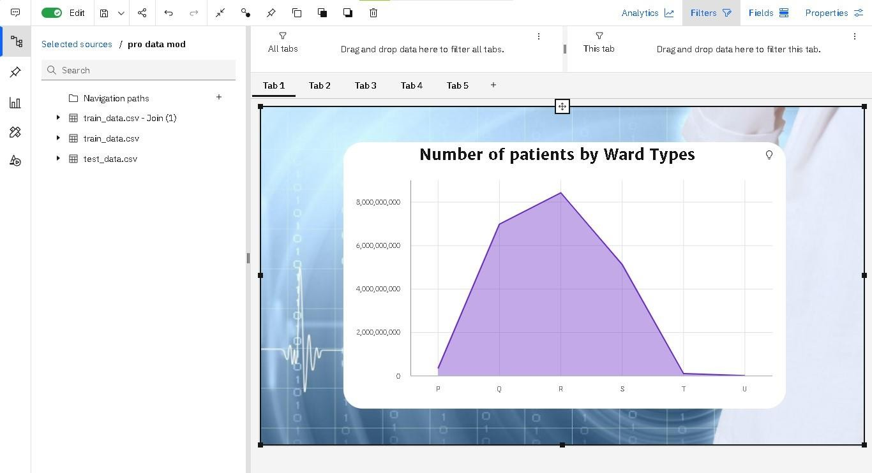

1. **Dashboard to Show Number of Patients**

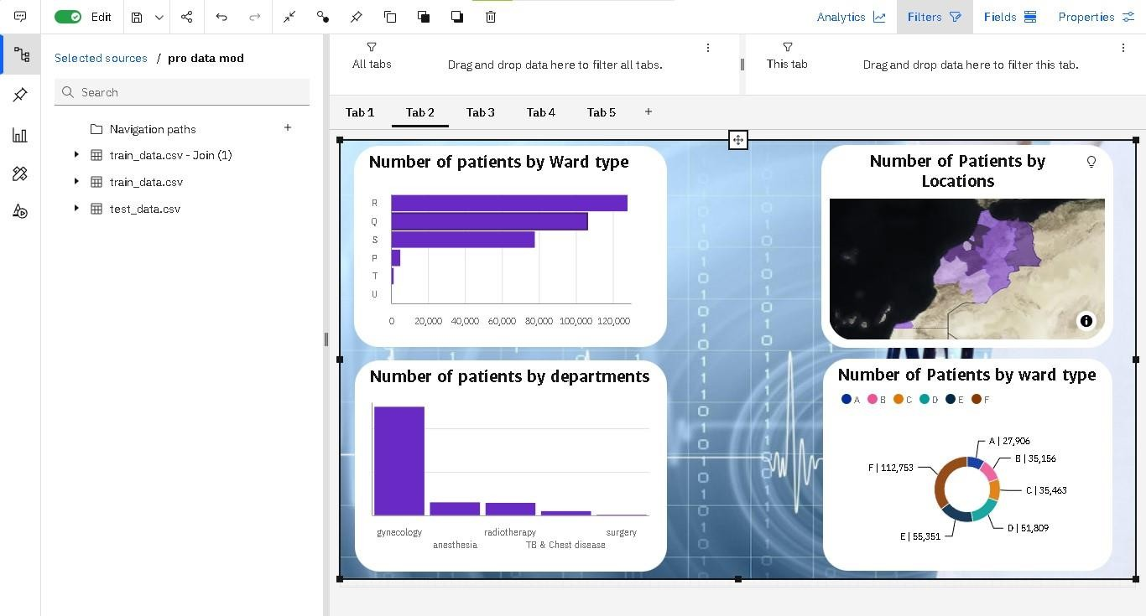

1. **Age Wise Patients with Department and Severity Filters**

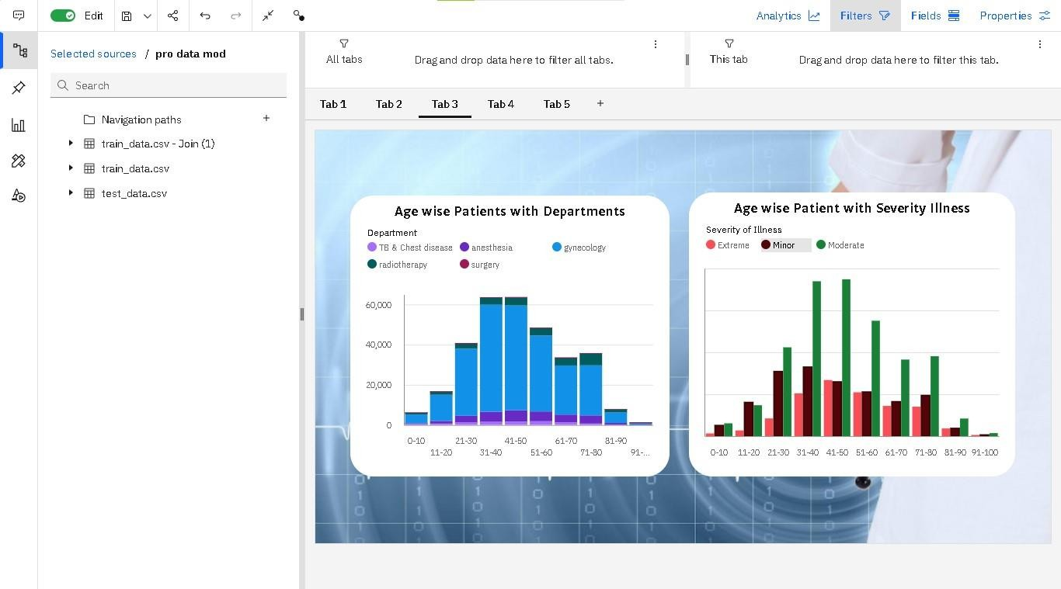

1. **Dashboard with Hierarchy Bubble and Radial Visuals**

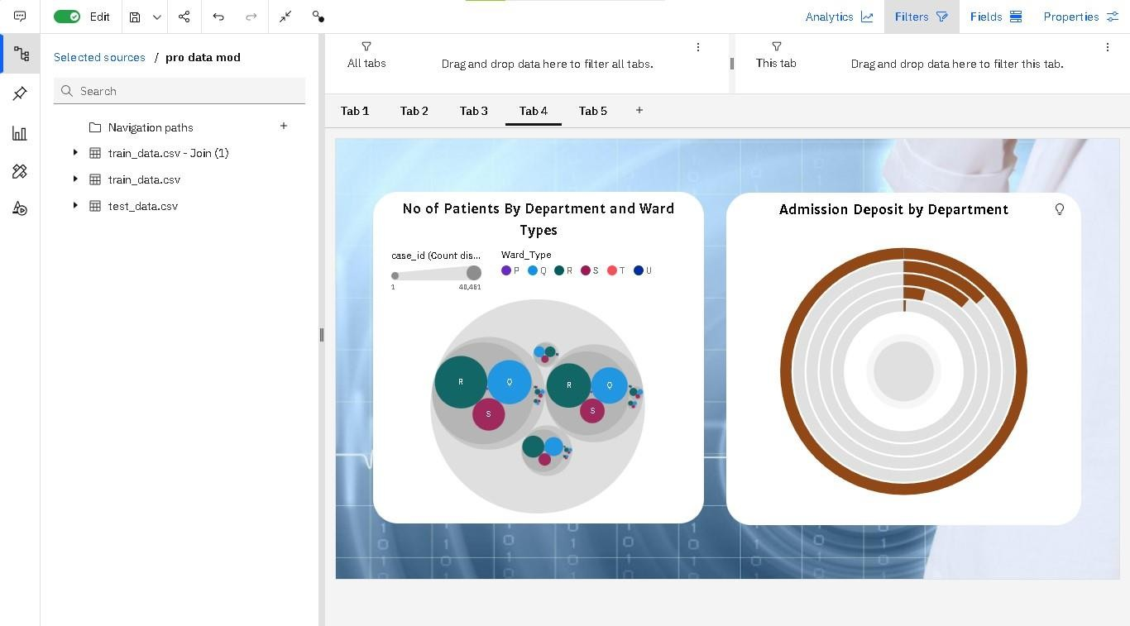

1. **Dashboard Showing Pie, Stacked Bar, Waterfall and Pie Charts**

